**BUG 1 – Discount change occurs with blank fields.**

**Bug ID:** 01

**Bug Summary:** When fields are empty, discount change occurs.

**Environment/URL:** [**https://qwallity-exam.onrender.com/**](https://qwallity-exam.onrender.com/)

**Operation System:** Windows 10 Home 64-bit

**Version**: 1

**Browser: -** Google Chrome

**Submit Date:** 6/17/2023

**Reporter:** Luiza Gevorgyan

**Steps to Reproduce:**

1. Open [**https://qwallity-exam.onrender.com/**](https://qwallity-exam.onrender.com/)

1. Login as admin.

2. Click on User_Action.

3. Click on Change Discount.

4. Choose Course type.

5. Leave the fields empty.

6. Click on Change Discount button.

**Expected Result:** Discount change shouldn’t occurs.

**Actual Result:** Discount change occurs.

**Screenshot/video: -**

**References: -**

**Severity:** Medium

**BUG 2 -** **Discount change occurs with invalid data.**

**Bug ID:** 02

**Bug Summary:** Discount and course_count accept values with letters, symbols, negative numbers

**Environment/URL:** [**https://qwallity-exam.onrender.com/**](https://qwallity-exam.onrender.com/)

**Operation System:** Windows 10 Home 64-bit

**Version**: 1

**Browser: -** Google Chrome

**Submit Date:** 6/17/2023

**Reporter:** Luiza Gevorgyan

**Steps to Reproduce:**

1. Open [**https://qwallity-exam.onrender.com/**](https://qwallity-exam.onrender.com/)

1. Login as admin.

2. Click on User_Action.

3. Click on Change Discount.

4. Choose Course type.

5. Fill in fields with invalid data.

6. Click on Change Discount button.

**Expected Result:** Discount change shouldn’t occurs.

**Actual Result:** Discount change occurs.

**Screenshot/video:-**

**References: -**

**Severity:** Critical

**BUG 3 – Notification is incorrect.**

**Bug ID:** 03

**Bug Summary:** After submission admin should see notification – ‘Discount changes’, but notification doesn’t match with requirement.

**Environment/URL:** [**https://qwallity-exam.onrender.com/**](https://qwallity-exam.onrender.com/)

**Operation System:** Windows 10 Home 64-bit

**Version**: 1

**Browser: -** Google Chrome

**Submit Date:** 6/17/2023

**Reporter:** Luiza Gevorgyan

**Steps to Reproduce:**

1. Open [**https://qwallity-exam.onrender.com/**](https://qwallity-exam.onrender.com/)

1. Login as admin.

2. Click on User_Action.

3. Click on Change Discount.

4. Choose Course type.

5. Fill in fields.

6. Click on Change Discount button.

**Expected Result:** Admin should see ‘Discount changes’.

**Actual Result:** Admin see ‘Discount is changed’.

**Screenshot/video:** Screenshot is attached.

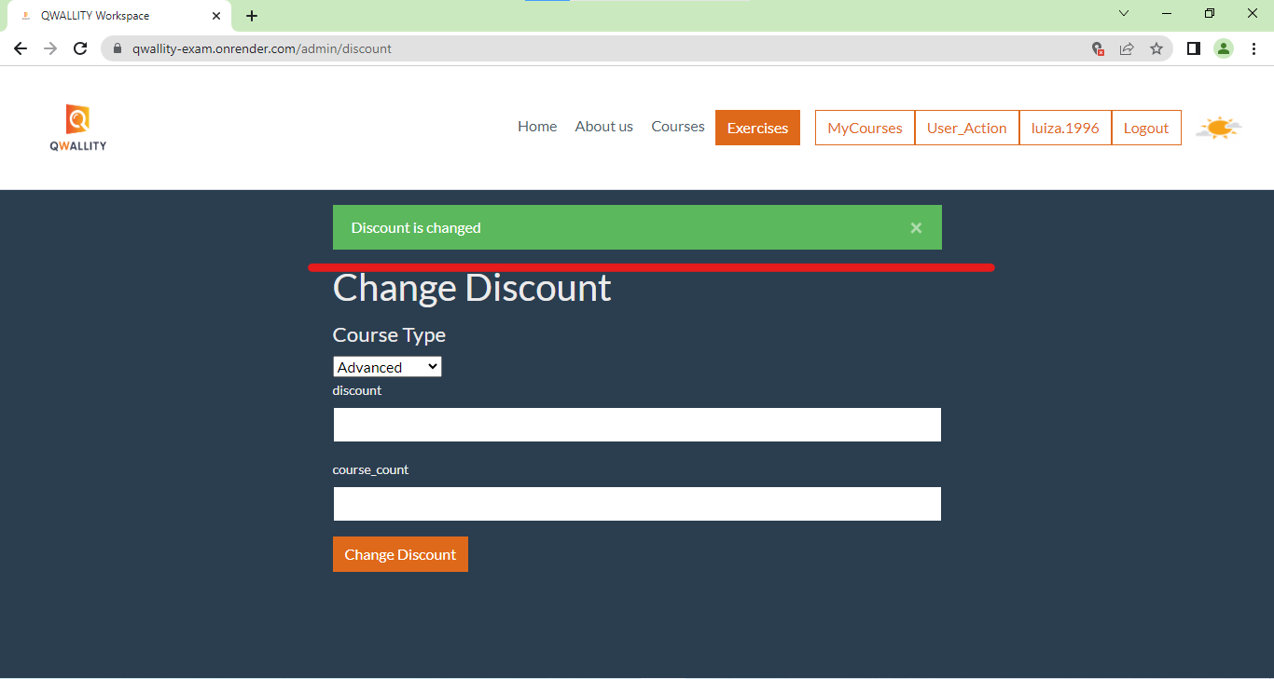

**References: -**

**Severity:** Low

**BUG 4 –The discount changes automatically.**

**Bug ID:** 04

**Bug Summary:** When we change the course type when buying a course, the discount changes automatically.

**Environment/URL:** [**https://qwallity-exam.onrender.com/**](https://qwallity-exam.onrender.com/)

**Operation System:** Windows 10 Home 64-bit

**Version**: 1

**Browser: -** Google Chrome

**Submit Date:** 6/17/2023

**Reporter:** Luiza Gevorgyan

**Steps to Reproduce:**

1. Open [**https://qwallity-exam.onrender.com/**](https://qwallity-exam.onrender.com/)

1. Login as non admin.

2. Click on Courses.

3. Choose Course type.

4. Choose Course.

5. Buy Course.

6. Change course type.

7. Buy new course, user see incorrect discount.

**Expected Result:** The discount must not be changed.

**Actual Result:** The discount is changing.

**Screenshot/video:-**

**References: -**

**Severity:** Critical

**BUG 5 – Functionality of discount change works incorrect.**

**Bug ID:** 05

**Bug Summary:** The system works incorrect. Discount change

**Environment/URL:** [**https://qwallity-exam.onrender.com/**](https://qwallity-exam.onrender.com/)

**Operation System:** Windows 10 Home 64-bit

**Version**: 1

**Browser: -** Google Chrome

**Submit Date:** 6/17/2023

**Reporter:** Luiza Gevorgyan

**Steps to Reproduce:**

1. Open [**https://qwallity-exam.onrender.com/**](https://qwallity-exam.onrender.com/)

1. Login as non admin.

2. Click on Courses.

3. Choose course type.

4. Choose course.

5. Click on Buy.

6. System shows discount with incorrect course_count.

**Expected Result:** Discount must apply with correct course_count.

**Actual Result:** Discount apply at once.

**Screenshot/video:-**

**References: -**

**Severity:** Critical

**BUG 6 – Price doesn’t show already discounted.**

**Bug ID:** 06

**Bug Summary:** After clicking buyprice shows actual cost of course.

**Environment/URL:** [**https://qwallity-exam.onrender.com/**](https://qwallity-exam.onrender.com/)

**Operation System:** Windows 10 Home 64-bit

**Version**: 1

**Browser: -** Google Chrome

**Submit Date:** 6/17/2023

**Reporter:** Luiza Gevorgyan

**Steps to Reproduce:**

1. Open [**https://qwallity-exam.onrender.com/**](https://qwallity-exam.onrender.com/)

1. Login as non admin.

2. Click on Courses.

3. Choose course type.

4. Choose course.

5. Click on Buy.

**Expected Result:** Price should be shown already discounted.

**Actual Result:** Price shows actual cost of course.

**Screenshot/video:** Screenshot is attached.

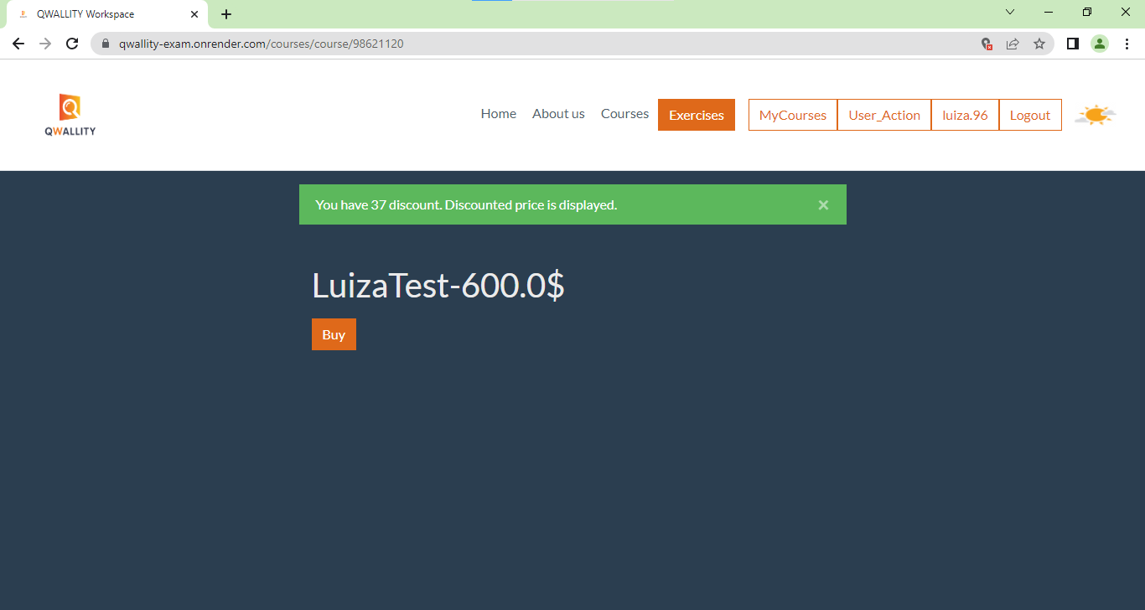

**References: -**

**Severity:** Medium